**ShoppyGlobe Backend- screenshots & GitHub Link:**

**Git- Hub Link:**

https://github.com/alpana15-mix/Shoppy-BackEnd.git

**1.Register API :**

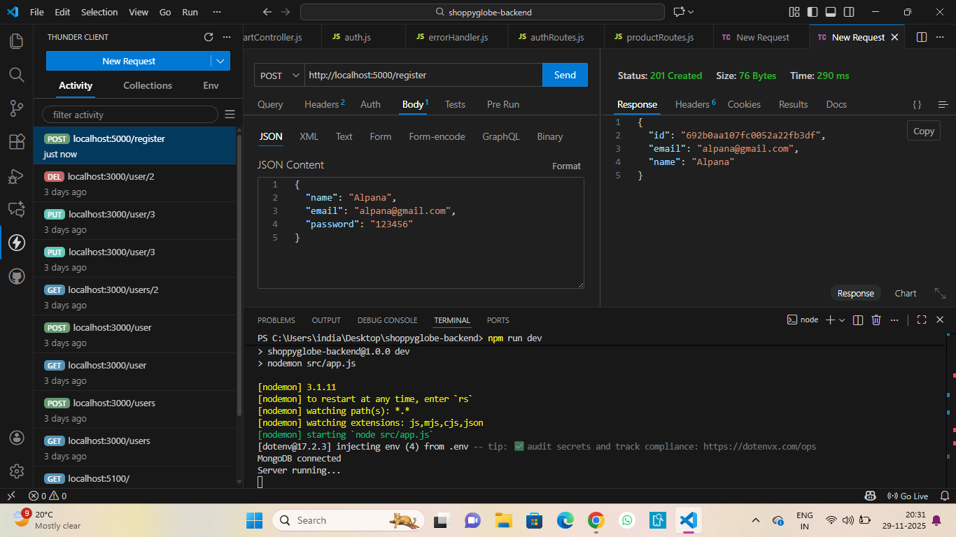

**2. Login API :**

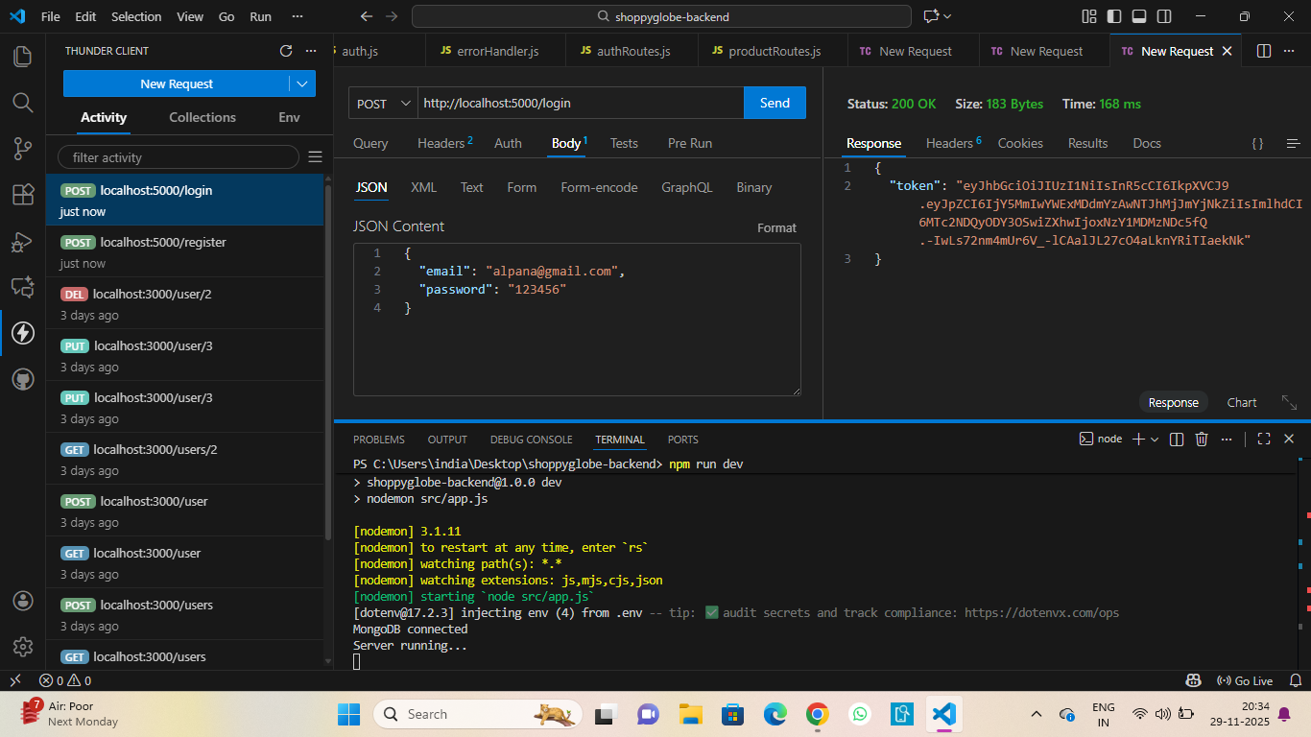

**3. Add Product API :**

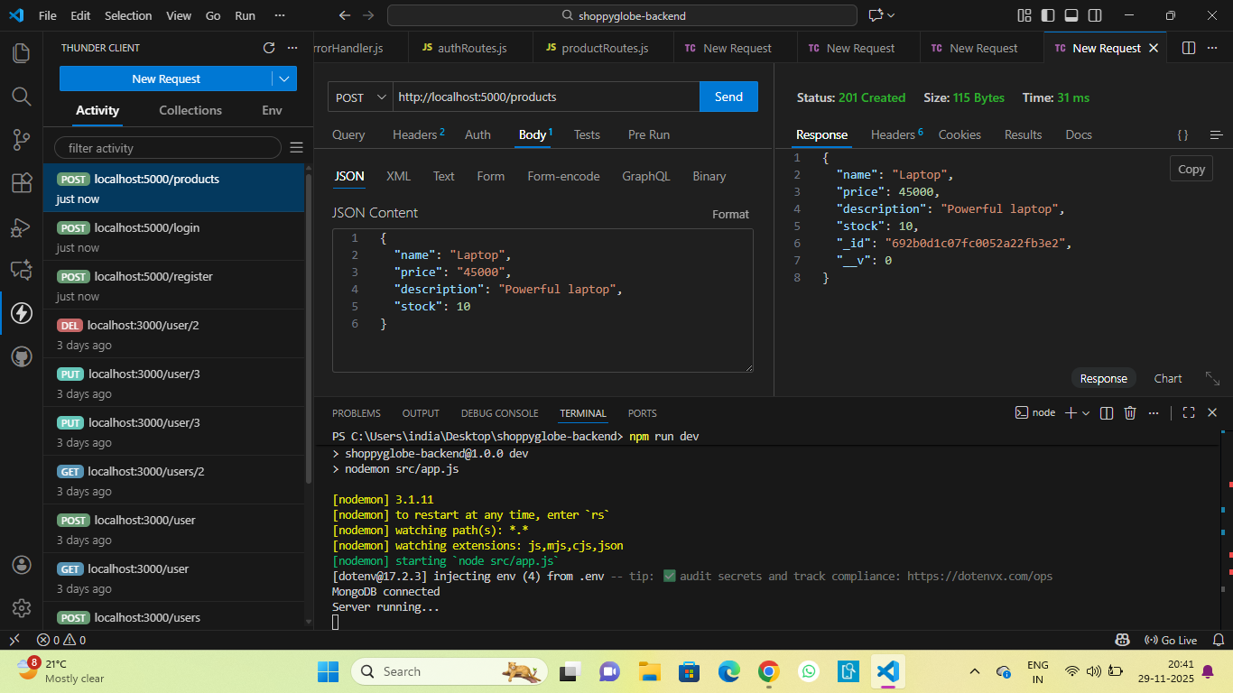

**4. Get All Products API :**

**5. Get Product by ID :**

**6. Add to Cart API :**

**7. Get Cart :**

**8. Update Cart API :**

**9. Delete Cart API :**

**10. MongoDB Users Collection :**

**11.MongoDB Products Collection :**

**12. MongoDB CartItems Collection :**

**13. Server Running :**